Seguici su Irene Firenze Irene_firenze

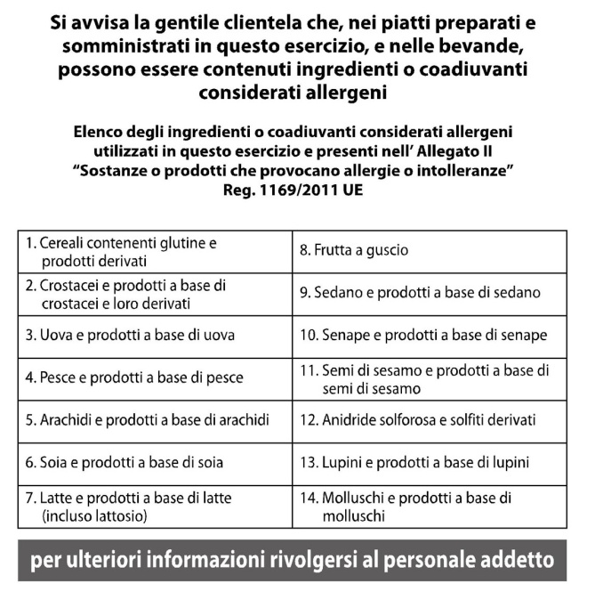

Piazza della Repubblica 7
Firenze

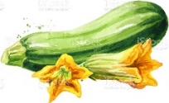

FOR STARTER

₍₄₎ Octopus salad,red rape and colored radicchio € 23
_{(1, 5, 14)} Fried calamari and vegetables € 22
_{(2, 7, 14)} Raw seabass with Sicilian pesto and lemon sorbet € 24
_{(1 ,3, 4)} Tartare of organic beef from Sig. Borgioli € 25
_{(3,7,9) “}Vitello tonnato” € 18
“Irene’s Salad”:
avocado, hearts of palm, tomatoes, lettuce, rocket, coriander € 18
Irene Salad served with Tuna or Mozzarella € 22
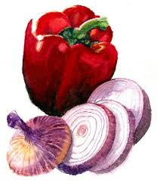
Mixed Salad € 12

PASTA and SOUP

(1, 3, 9) Tuscan Bean soup, Sage ravioli, caramelized Celery € 20
(1,2) Linguine with Lobster € 38
(1, 3, 7) Lasagnetta pasta with “Chianina” ragout € 23
(1, 3, 7) Ravioli stuffed with “Pappa al Pomodoro” € 22
(7) Risotto with saffron, red prawns and pistachio € 25
(1, 7) Spaghetti, Tomato and Basil € 22

MAIN COURSE

(7,4) Turbot, chickpeans cream, escarole and truffle € 36
(4) Mixed grilled fish € 37
(4, 7) Seabass, olive oil mashed potatoes and artichokes € 35
(1, 7) Mini Veal Milanese with Rice cake and green Beans € 29
(7, 8) Organic filet Beef cooked on a Himalayan salt plate € 38
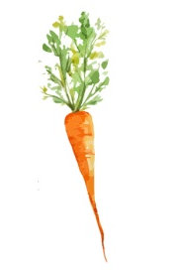

SIDE DISHES

(7) Beans from Valdarno with olive oil and black pepper € 8
(7) Olive oil mashed potatoes € 8
Grilled vegetables:
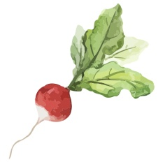
egglapant, zucchini, tomato, endive, radicchio, pumpkin, pepper € 13
(7) Roasted potatoes with rosemary € 8

